class04.R

juangonzalez

2024-10-12

#my first Rscript  
x<-1:50  
plot(x)

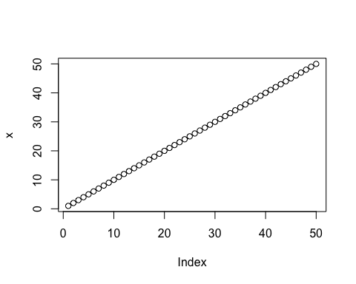

plot(x, sin(x), type="l", col="blue")

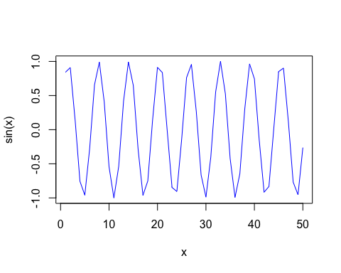

#you can stick with the plot(x, sin(x)) to create the same graph  
plot(x=x, y=sin(x), typ="l", col="yellow", lwd="7")

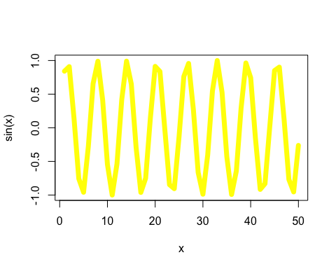

log(10,2)

## [1] 3.321928